NTSAKO VALENTIAH BALOYI ASSIGNMENT 1 DECODELABS
CLEANED DATASET
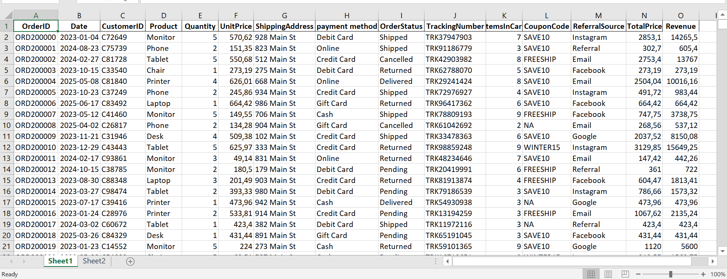
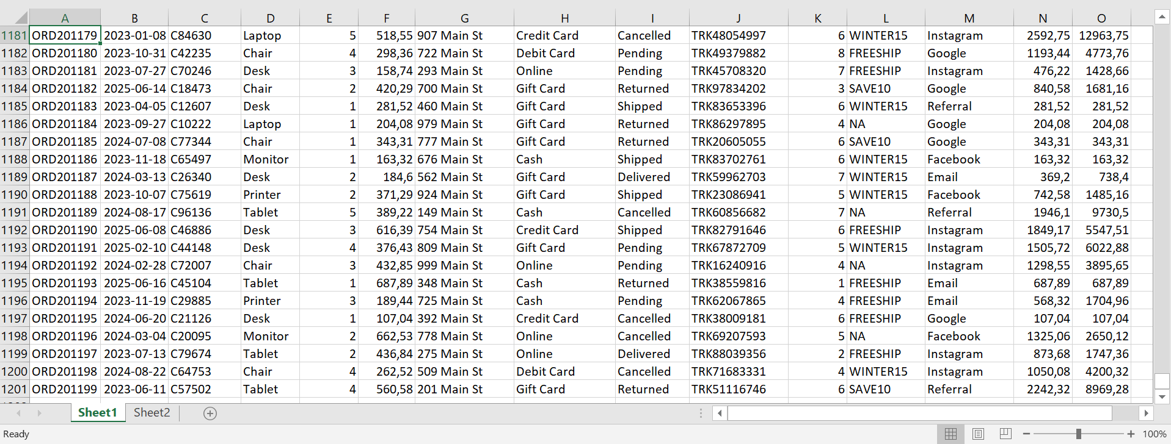

1. MISSING VALUES HANDLED
• Column with missing data: Coupon Code
• Action taken: Filled blank cells with NA
• Result: 0 missing values remaining

2. DUPLICATES REMOVED
• Column checked: OrderID (Primary Key)
• Method: Excel → Data → Remove Duplicates
• Result: 0 duplicates found

3. DATE FORMAT CORRECTED
• Column checked: Date
• Format verified: YYYY-MM-DD (Excel Date format)
• Result: All 1,200 dates properly formatted

4. TEXT & NUMERIC DATA STANDARDIZED
• Text columns cleaned: Product, payment method, OrderStatus, ReferralSource
• Numeric columns validated: Quantity, UnitPrice, TotalPrice, Revenue
• Result: Consistent formatting across all fields

MANDATORY REQUIREMENTS MET

- Zero duplicate OrderIDs confirmed
- Zero incorrectly formatted dates confirmed
- All missing values appropriately handled
- Dataset saved and ready for analysis

FINAL VERIFICATION

• Total records processed: 1,200
• Records after cleaning: 1,200 (no data lost)
• Data integrity: 100%

CONCLUSION

The raw dataset has been successfully cleaned. All missing values, duplicates,
and formatting issues have been resolved. The dataset is now ready for
exploratory analysis and reporting in Project 2.

